POWER BI SALES ANALYSIS REPORT
Sales Overview Dashboard
Name | S. Thamilarasi
Roll No | E25FA048
Department | B.Com FinTech with AI

1. Introduction
This report presents the Power BI Sales Overview dashboard created to monitor key sales and order-related measures. The dashboard combines summary cards with graphical visualizations so that important business information can be understood quickly.

2. Objectives
- To summarize important sales and order measures in a single dashboard.
- To observe monthly sales trends using a line chart.
- To compare sales performance across product categories.
- To compare the number of orders handled by employees.
- To display the number of customers and other key indicators using KPI cards.

3. Dashboard Visualizations
Visualization | Measure / Field | Purpose
KPI Card | Average Freight | Shows the average freight value.
KPI Card | Total Freight | Shows the overall freight value.
KPI Card | Total Quantity Sold | Shows the total quantity sold.
KPI Card | Total Orders | Shows the total number of orders.
KPI Card | Number of Customers | Shows the number of customers.
Line Chart | Order Date (Month) + Total Sales | Shows the monthly sales trend.
Column Chart | Category Name + Total Sales | Compares total sales across categories.
Bar Chart | Employee Name + Total Orders | Compares orders associated with employees.

4. Visualization Summary
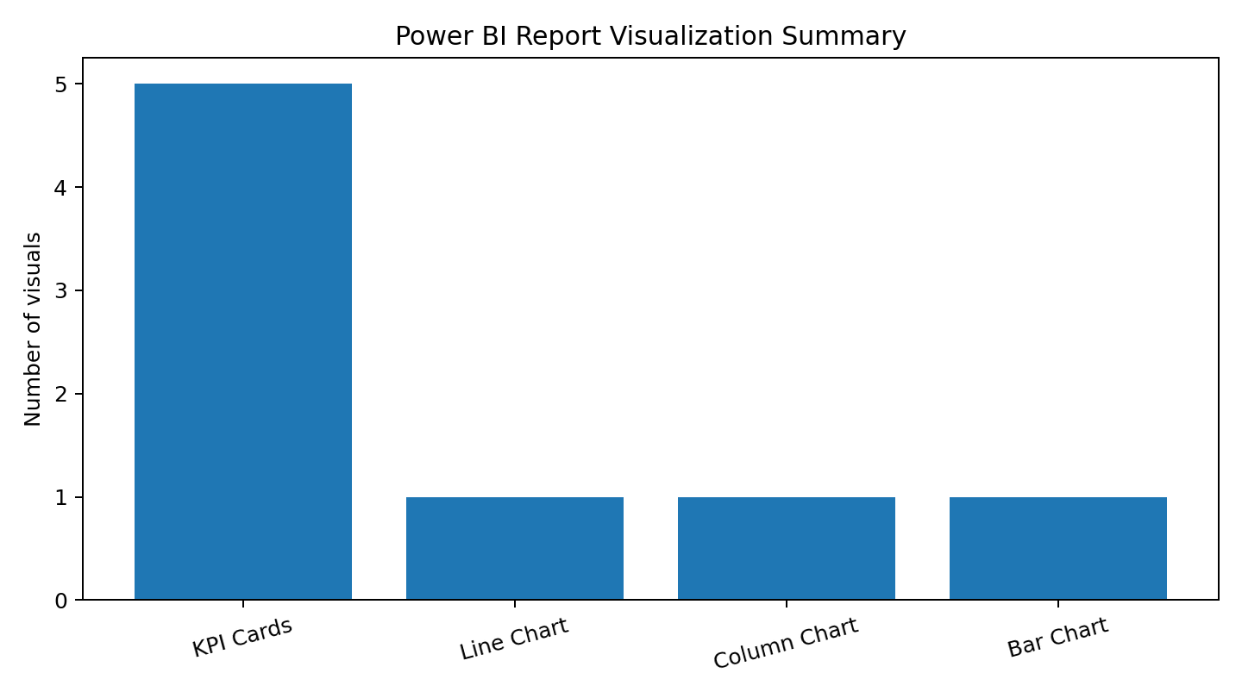
The uploaded PBIX contains eight main visuals: five KPI cards, one line chart, one clustered column chart, and one clustered bar chart. This chart summarizes the composition of the dashboard rather than reporting business values.

5. Interpretation of the Dashboard
KPI Cards: The KPI cards provide a quick snapshot of freight, quantity, orders, and customer measures. They are useful for checking the overall position of the business before examining detailed trends.
Monthly Sales Trend: The line chart uses order date by month with Total Sales. It helps identify changes in sales over time, including periods of increase or decrease.
Category Comparison: The clustered column chart compares Total Sales across product categories. This makes differences between categories easier to identify.
Employee Order Comparison: The clustered bar chart compares Total Orders by employee. It provides a simple view of how order counts are distributed across employees.

6. Key Findings from the Dashboard Design
- The dashboard uses a combination of summary and detailed visuals.
- The KPI cards are positioned for quick monitoring of important measures.
- The monthly line chart supports time-based sales analysis.
- Category and employee visuals support comparison between business groups.
- The dashboard structure allows users to move from overall performance to more detailed analysis.

7. Conclusion
The Power BI Sales Overview dashboard provides a clear and interactive approach to sales analysis. By combining KPI cards, a monthly sales trend, category comparison, and employee order comparison, the report helps users understand business performance from different perspectives. The dashboard demonstrates how Power BI visualizations can convert business data into an easy-to-understand analytical report.

Prepared by: S. Thamilarasi | E25FA048 | B.Com FinTech with AI

